**A Virtual and Augment Reality Application for Chemical Experiment Education and Practice**

XiaoYun Duan

# Abstract

Virtual reality (VR) and Argument reality(AR) technology have open a vast opportunity to be applied in many fields include education. This paper is based on a research of the conventional chemistry experiment education limitations, we developed a "Virtual Chemistry Lab" propose a new method of assisting present teaching aids. And through analyzing different interaction methods in the VR system, find the better applicable interaction mode for this application. By evaluation, implementation of this application achieved the education objective more effectively.

*Keywords: Virtual reality (VR), Argument reality(AR), Chemistry education*

# Introduction

The conventional education system modes are primarily passive or receptive learning style, many teachers think that students learned the experimental principle and method is important and enough, so they no need to do many experiments, according to our research, present teaching methods have limits shows as below: First: Lack of motivation and of activity, students are shown the experiments results instead of probing the results. Second: Temporal and spatial constraints; students cannot do the experiments anytime and anywhere for the limits of objective conditions, and cannot repeat the experiment steps. Third: Wasted reagents and danger, some of the reagents are dangerous, therefore many practices are requisite before using the real ones. In this way can save the reagents and lessen the danger. To break the limits as we build up this application, use this can let the users practice the experiments wherever and whenever they need in a more active and probing learning way, and can also can save the reagents and lessen the danger probability. Meanwhile compare to the 2d chemistry applications it guarantees the immersion almost alike the real world, in addition we also design a feature that users can see the microcosmic things like molecular structure using mark AR. All the solutions are confirmed Improved learning efficiency.

# Related works

**1, VR and AR technologies**

Virtual reality(VR) that uses a computer that creates a simulated 3D world. Jerald et al, [2] presented that VR is defined as “a computer-generated digital environment that can be experienced and interacted with as if that environment were real” and asserted that VR is communication, they emphasized the importance of human factor that influence the interaction between the VR system and the users [2]. VR uses computer or other devices, simulates and generates a virtual world that the users can interact with, and get immersive experience.

Since 2014, Oculus, HTC Vive, Gear VR, etc have a booming development, VR applications are spread in our life such as game, study, work , traveling and many other fileds. In this paper we use Oculus which is connected to PC and Gear VR which is connected with smartphone.

Augmented reality (AR) integrates computer display into real-world environments and enhances environment of real world. Lately in last month, Google published a brand new android SDK called “AR Core”, corresponding to this Apple has the “AR Kit” for iOS, Both are brand new so that are under testing. In this paper we create a simple feature in augmented reality using Unity 3D [3] and Vuforia SDK [4] that is for creating AR applications in mobile devices. Vuforia was originally developed by Qualcomm and optimized for their chipsets aiming primarily at mobile performance. The features of Vuforia are extremely varied range of marker types.

**2, Interaction ways**

Introduce the VR interaction ways……? (eye tracking, body tracking, controllers,…)

In this paper, the interaction models are as follows, Since the LeapMotion is not support to mobile so far and Vuforia AR is not support PC executable file, among these ways we choose PC + Oculus HMD + Controller for a more precise experiment , and Mobile +PC + LeapMotion + AR way for a cheap device experiment.

* PC + Leap Motion + AR
* PC + Oculus VR/HTC HMD and Controller+ AR (√)
* Mobile + PC+ Leap Motion+ AR (√)
* Mobile + Controller+ AR

# Project Design

**1, User Interface**

The UI is Under the Screen coordinates, for VR mode users can choose and do the experiments in the virtual lab, and for the AR mode the camera is needed and users can learn some extend chemistry knowledges using the AR cards.

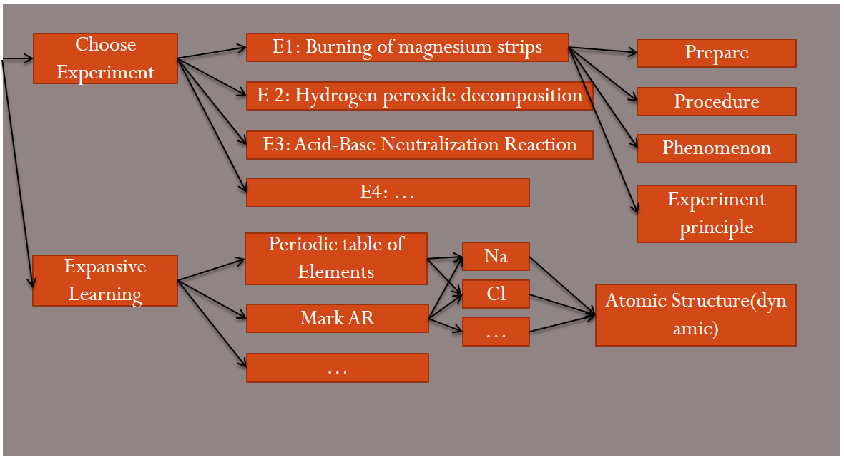

**AR**

**VR**

Fig.2 user interface

**2, VR Chemistry Lab Scene**

When user choose the desirable experiment, the VR chemistry Lab Scene is shown as the  Fig3 below , like a Simple real Lab there is a Laboratory Furniture, and on the table there are some experiment instrument that needed in the chosen experiment, in the Experiment 1, there are Alcohol Lamp, beaker , magnesium strips, etc on the table.

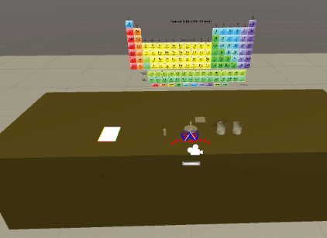 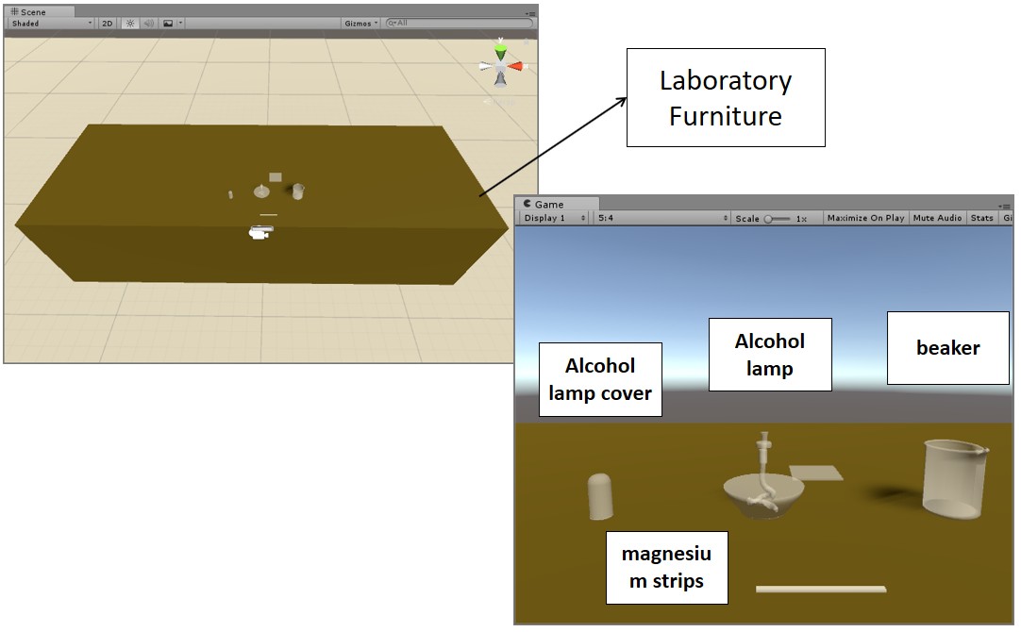

Fig. 3

**2, Interaction design**

we use LeapMotion as the interaction tool ,users’ hand is recognized as fig4 below.

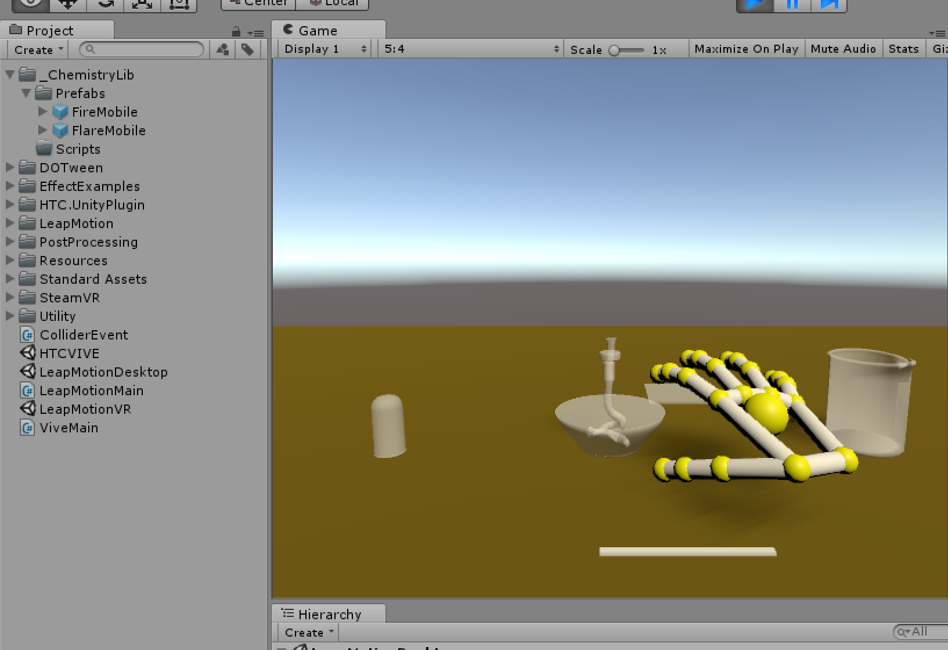

Fig. 4 Interaction design

2.1 [Definition of hand gesture](javascript:;)s for LeapMotion hand control Mode

[Define some gesture](javascript:;)s that can interact with the object more accurate, such as lighting the alcohol lamp by pointing (with one index finger) the top of the alcohol lamp。

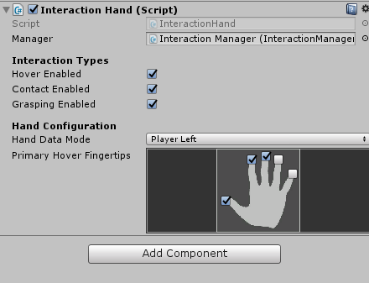 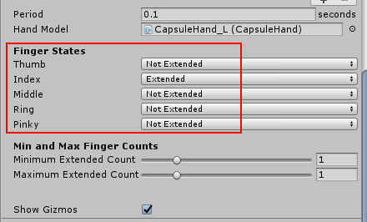

Fig. 5 [Definition of hand gesture](javascript:;)s: Lighting the alcohol lamp by pointing with the index finger

# Experience

**1, Experimental procedure**

1.1 Burning of magnesium strips

* Read the guidelines or videos on the desk (mark AR)
* Grab the match on the desk and Lighting alcohol lamp
* Put on the goggles
* Use a pair of tweezers to clip one of the two magnesium strips on the table and burn one on the alcohol lamp
* See and record the phenomenon
* Put the burned magnesium strips in a beaker containing vinegar, Put the other(unburned) magnesium strips in a beaker containing vinegar
* See and record the phenomenon
* Extinguishing alcohol lamp

1.2 Hydrogen peroxide decomposition experiment……?

* See and record the phenomenon
* …

# Conclusion

# References

[1] The Virtual Lab (Physics & Chemistry) for Malaysia’s Secondary School [accessed Oct 3, 2017].

[2] Jason Jerald, “The VR book,” What is Virtual Reality? ACM Books #8 pp. 9-15. 2014

[3] Unity 3D, [Article(CrossRef Link)](https://madewith.unity.com/)

[4] Vuforia SDK, [Article(CrossRef Link)](https://www.vuforia.com/)

[5]

[6]

[7]

[8]